# 4. 3D Introduction

COMP3421 Computer Graphics • KC Notes

## 4.1 Coordinates

* 3D coordinate system is **right handed coordinate system**
  + Thumb x, index y, middle z
* **Depth**: OpenGL draws objects in the order in which they are generated in code
* **Projection**: map geometry in a 3D space to a 2D image, but looks 3D to our eyes
* **Winding order**: triangles defined with counter-clockwise vertices
  + Front side has counter-clockwise vertices
* **Back face culling**: optimisation that culls non-visible triangles (back faces) before rasterization, avoids unnecessary fragments from being created
  + gl.glEnable(GL.GL_CULL_FACE);

## 4.2 3D transformations

* Transformations have same structure but extra axis $k$:
$$M=\left(\begin{matrix}i_{1} & j_{1} & k_{1} & ϕ_{1} \\ i_{2} & j_{2} & k_{2} & ϕ_{2} \\ i_{3} & j_{3} & k_{3} & ϕ_{3} \\ 0 & 0 & 0 & 1\end{matrix}\right)$$

* Translation:
$$M_{T}=\left(\begin{matrix}1 & 0 & 0 & ϕ_{1} \\ 0 & 1 & 0 & ϕ_{2} \\ 0 & 0 & 1 & ϕ_{3} \\ 0 & 0 & 0 & 1\end{matrix}\right)$$

* Scale:
$$M_{S}=\left(\begin{matrix}s_{x} & 0 & 0 & 0 \\ 0 & s_{y} & 0 & 0 \\ 0 & 0 & s_{z} & 0 \\ 0 & 0 & 0 & 1\end{matrix}\right)$$

* Shear:
$$M_{H}=\left(\begin{matrix}1 & h & 0 & 0 \\ 0 & 1 & 0 & 0 \\ 0 & 0 & 1 & 0 \\ 0 & 0 & 0 & 1\end{matrix}\right)$$

* Rotation: depends on axis of rotation
  + Any rotation can be decomposed into a sequence of rotations about x, y and z axes
* Right hand rule:
  + Rotation of x: y moves towards z
 $$M_{x}=\left(\begin{matrix}1 & 0 & 0 & 0 \\ 0 & cos⁡θ & -\sin{θ} & 0 \\ 0 & \sin{θ} & \cos{θ} & 0 \\ 0 & 0 & 0 & 1\end{matrix}\right)$$

 + Rotation of y: z moves towards x
 $$M_{y}=\left(\begin{matrix}\cos{θ} & 0 & -\sin{θ} & 0 \\ 0 & 1 & 0 & 0 \\ \sin{θ} & 0 & \cos{θ} & 0 \\ 0 & 0 & 0 & 1\end{matrix}\right)$$

 + Rotation of z: x moves towards y

$$M_{z}=\left(\begin{matrix}\cos{θ} & -\sin{θ} & 0 & 0 \\ \sin{θ} & \cos{θ} & 0 & 0 \\ 0 & 0 & 1 & 0 \\ 0 & 0 & 0 & 1\end{matrix}\right)$$

## 4.3 Cube

* Draw a TriangleFan square face (anticlockwise) with z = 1
* Rotate square face along Y and X axes
* Rotate coordinate frame

## 4.4 Orthographic projection

* In 2D, camera is represented by a square. In 3D, it is a **view volume**
* 3D camera can be defined as **a 3D point and orientation**, points backwards
* **View volume**: Area of space that will be displayed in the viewport
  + Objects outside are **clipped**
* Have values left, right, top, bottom, near and far
* **Project a point** from 3D view volume onto the **near plane**, and then map to the viewport
  + Projection happens **after model and view transformations**
  + Points with negative z values are in front of the camera (e.g. near = 2 puts at z = -2)
* **Depth, orthographic**: While we could map points directly to the near plane, we want to **retain depth information** – projection matrix should map z-values of visible points to be between -1 (near) and 1 (far)
  + **CVV: canonical view volume, with** clipping coordinates, scaled to the range (-1, 1) with z-axis flipped
  + Preserves parallel lines, describes shapes completely and exactly

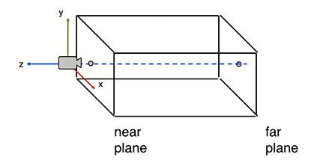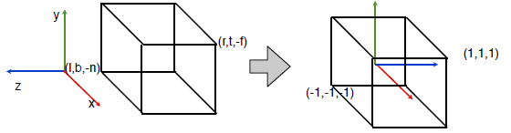

* Map x, y points using $q_{1}=p_{1}$, $q_{2}=p_{2}$:

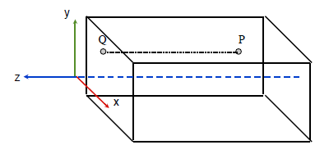

* This transformation is mapped via the **orthographic transformation matrix**
  + $l, r$ the left and right, $t, b$ the top and bottom, $n, f$ the near and far planes
  + For Matrix4.orthographic(-1, 1, -1, 1, 1, 10); only z changes

$$M_{O}=\left(\begin{matrix}\frac{2}{r-l} & 0 & 0 & -\frac{r+l}{r-l} \\ 0 & \frac{2}{t-b} & 0 & -\frac{t+b}{t-b} \\ 0 & 0 & -\frac{2}{f-n} & -\frac{f+n}{f-n} \\ 0 & 0 & 0 & 1\end{matrix}\right)$$

## 4.5 Perspective projection

* **Foreshortening**: things appear smaller as they are further away
  + Biology of the eye – objects hit the pupil at different locations
* **Frustum**: view volume like a square pyramid with top cut off
  + Points get mapped to the near plane, objects far away get smaller when mapped
  + Matrix4.frustrum(-1, 1, -1, 1, 1, 10);

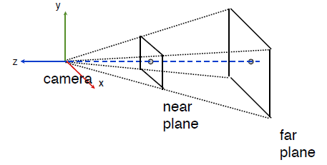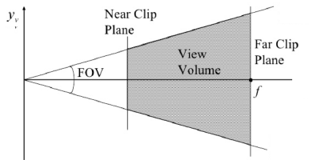

* Projection is easier to represent with near, far planes, and:
  + fovy, the vertical **field of view**: $\tan\left(\frac{FOV}{2}\right)=\frac{height}{2×near}$, usually 60
  + aspectRatio, $aspectRatio=\frac{width}{height}$
* Map x, y point using $q_{1}=n\frac{p_{1}}{-p_{3}}, q_{2}=n\frac{p_{2}}{-p_{3}}$
* Map depth using **pseudodepth**, a non-linear value mapped between -1 and 1:
  + Objects far away do not change size as much, approximate close things better
$$q_{3}=\frac{ap_{3}+b}{-p_{3}}, a=-\frac{f+n}{f-n}, b=-\frac{2fn}{f-n}$$

* **Generalise homogenous coordinates**, 4th component of a point can be any value $≠0$
  + Allows us to apply some non-linear operations to our point
  + Transformation is not affine (results in non-parallel lines)
* Combining perspective transformation with CVV (use right one):

$$M_{perspective}=\left(\begin{matrix}n & 0 & 0 & 0 \\ 0 & n & 0 & 0 \\ 0 & 0 & a & b \\ 0 & 0 & -1 & 0\end{matrix}\right), M_{P}=\left(\begin{matrix}\frac{2n}{r-l} & 0 & \frac{r+l}{r-l} & 0 \\ 0 & \frac{2n}{t-b} & \frac{t+b}{t-b} & 0 \\ 0 & 0 & -\frac{f+n}{f-n} & -\frac{2fn}{f-n} \\ 0 & 0 & -1 & 0\end{matrix}\right)$$

## 4.6 Final Steps

* With CVV coordinates, **perspective division step** – divide by 4th component to make it 1
* **Viewport transformation**: scaled into window coordinates corresponding to pixels on screen
  + Maps pseudodepth from (-1, 1) to (0, 1)

$$M_{viewport}=\left(\begin{matrix}\frac{w_{s}}{2} & h & 0 & s_{x}+\frac{w_{s}}{2} \\ 0 & \frac{h_{s}}{2} & 0 & s_{y}+\frac{h_{s}}{2} \\ 0 & 0 & \frac{1}{2} & \frac{1}{2} \\ 0 & 0 & 0 & 1\end{matrix}\right)$$

## 4.7 Final pipeline

1. From point $P={\left(p_{1},p_{2},p_{3}\right)}^{T}$
2. Extend to **homogeneous coordinates $P={\left(p_{1},p_{2},p_{3},1\right)}^{T}$**
3. Multiply by **model matrix** to get world coordinates $P_{w}=M_{model}P$
4. Multiply by **view matrix** to get camera coordinates $P_{C}=M_{view}P_{w}$
5. Multiply by **projection matrix** to get CVV coordinates $P_{CVV}=M_{perspective}P_{C}$
6. **Clip** to remove points outside CVV
7. **Perspective division** to eliminate 4th component $P_{n}=\frac{1}{p_{4}}P_{CVV}$
8. **Viewport transformation** to window coordinates $P_{v}=M_{viewport}P_{n}$

## 4.8 OpenGL vertex shader

|  |  |
| --- | --- |
| // Incoming vertex position  in vec3 position;  uniform mat4 model_matrix;  uniform mat4 view_matrix;  uniform mat4 proj_matrix;  void main() {  // Global position in homogenous coordinates  vec4 globalPosition = model_matrix *   vec4(position, 1);  // Position in camera coordinates  vec4 viewPosition = view_matrix * globalPosition;  // Position in CVV coordinates  gl_Position = proj_matrix * viewPosition;  // OpenGL will do steps 6-8  } | |
|  |  |

## 4.9 Fragments

* **Rasterisation**: converting triangles into collections of fragments
  + Vertex is cheap, fragment is expensive
  + Culled triangles are discarded (e.g. back-face culling)
  + Fragment corresponds to a single image pixel
  + Fragment may not make it to final image if it is discarded by depth testing
* **Hidden surface removal**: discard fragments that shouldn’t be seen
  + Make sure primitives are drawn in the right order on the **model level**, not OpenGL
  + Use **depth buffer** on the **fragment level**
* **Painter’s algorithm**: sort primitives by depth, draw from back to front, sort is expensive
  + Triangles do not have a single z value, items may overlap each other – BSP trees
    - Recursively divide world into polygons
* **Depth buffer**: keep per-pixel depth information, store in a depth buffer
  + Initially cleared to 1, polygon drawn fragment by fragment
  + If closer (depth less than 1), update pixel in colour buffer, update buffer with pseudodepth

|  |  |
| --- | --- |
| // Turn on the depth buffer  gl.glEnable(GL.GL_DEPTH_TEST);  // Clear the screen with the defined clear color  gl.glClear(GL.GL_COLOR_BUFFER_BIT | GL.GL_DEPTH_BUFFER_BIT); | |
| initialise db[x][y] = 1 for all x,y  for each triangle:  for each fragment (px,py):  d = pseudodepth of (px,py)  if (d < db[px][py]):  draw fragment  db[x][y] = d | |
|  |  |

## 4.10 Pseudodepth, bilinear interpolation

* Interpolate R1 and R2 using y axis
$$f\left(R_{1}\right)=\frac{y-y_{1}}{y_{2}-y_{1}}f\left(Q_{2}\right)+\frac{y_{2}-y}{y_{2}-y_{1}}f\left(Q_{1}\right) \\ f\left(R_{2}\right)=\frac{y-y_{3}}{y_{4}-y_{3}}f\left(Q_{4}\right)+\frac{y_{4}-y}{y_{4}-y_{3}}f\left(Q_{3}\right)$$

* Then with those two values, interpolate P using x axis

$$f\left(P\right)=\frac{x-x_{1}}{x_{2}-x_{1}}f\left(R_{2}\right)+\frac{x_{2}-x}{x_{2}-x_{1}}f\left(R_{1}\right)$$

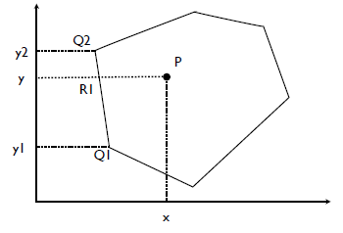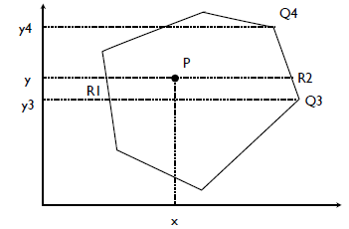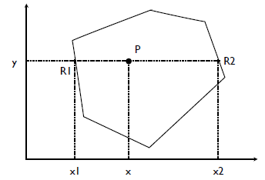

## 4.11 Problems with depth

* **Z-fighting**: depth buffer has limited precision (usually 16 bits)
  + If almost parallel, small rounding errors causes fighting
  + Using a small offset causes a gap when looked at sideways
* glPolygonOffset: draws normally but only offset depth buffer
* gl.glEnable(GL.GL_POLYGON_OFFSET_FILL);
* gl.glPolygonOffset(factor, units); calculated as $o=m×factor+r×units$
  + m the depth slope of the polygon, r the smallest resolvable difference in depth
  + Usually 1, 1 for backwards, or -1, -1 for forwards